Free File Propagate Documentation
I offer this program for free to anyone who wants to try it out. I have been teaching myself Python 3 since losing my job about a year ago, and this utility is a continuation of my attempt to put my knowledge to a practical use. If you find it useful and want to donate a buck or two to the unemployed programmer who wrote it you can use the following link to do so: Donate
Screenshot 1:
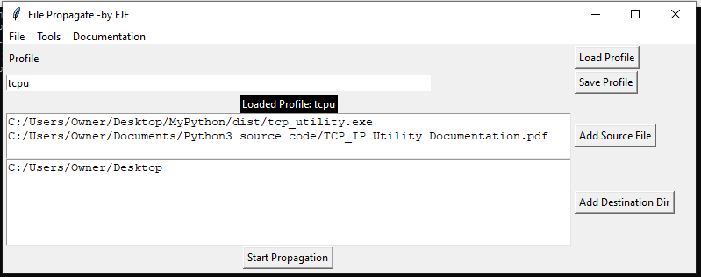
Click on the “Add Source File” button to open a bowser and select a file to add to the source file window (below the status line and above the destination directory window”).
Click on the “Add Destination Dir” button to open a browser and select a destination directory to add to the destination directory window.
Clicking the “Start Propagation” button will start the process. Each file in the source file list will be looked for in each destination directory entered, if the source file does not exist in a destination directory a copy of the source file will be created in the destination directory, this will increment the “Copied:” counter value (shown as Created on the summary line). If the file does exist in the destination directory this program then compares the last modified values and if the source file is more recent then the file on the destination drive, the destination’s file is replaced with the source file and the “Updated:” count will increase, if the file on the destination directory is not older then the source file “Not Old:” counter is incremented. There is also an “Errors:” counter that will be incremented if the program encounters any errors while propagating the source files. These counter values will be displayed on the status line after the source files have been processed.

Screen shot 2:
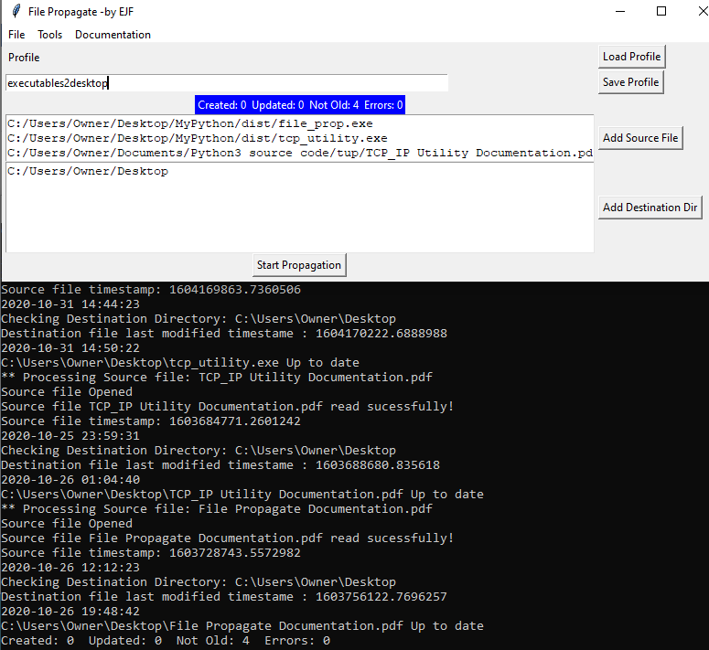

If launched from a “Command Prompt” session details of each source file and the actions taken for them are diplayed in the command prompt session. If launched from windows a “console” session will launch with the File Propagate window and the detials of the actions on the source files will be displayed on that console session.
If installed via the .deb file for Debian Linux the data directory fpd (used to store profile data and this documentation file) will be created off the /home/user/Documents directory (where the user value is the linux user name).

